# Delavnica robotike OŠ Tolmin 2019 - Sledibot

## ARDUINO IO PINOUT

|  |  |  |
| --- | --- | --- |
| Digital | | |
| Arduino Pin | type | function |
| D0 | RX | RESERVED |
| D1 | TX | RESERVED |
| D2 | DIGITAL OUT | MOTOR 1 LEFT |
| D3 | DIGITAL OUT | MOTOR 1 RIGHT |
| D4 | DIGITAL OUT | MOTOR 2 LEFT |
| D5 | DIGITAL OUT | MOTOR 2 RIGHT |
| D6 |  |  |
| D7 |  |  |
| D8 |  |  |
| D9 |  |  |
| D10 |  |  |
| D11 |  |  |
| D12 |  |  |
| D13 |  |  |

|  |  |  |
| --- | --- | --- |
| Analog | | |
| Arduino Pin | type | function |
| A0 |  |  |
| A1 |  |  |
| A2 |  |  |
| A3 |  |  |
| A4 |  |  |
| A5 |  |  |

## SHEMA

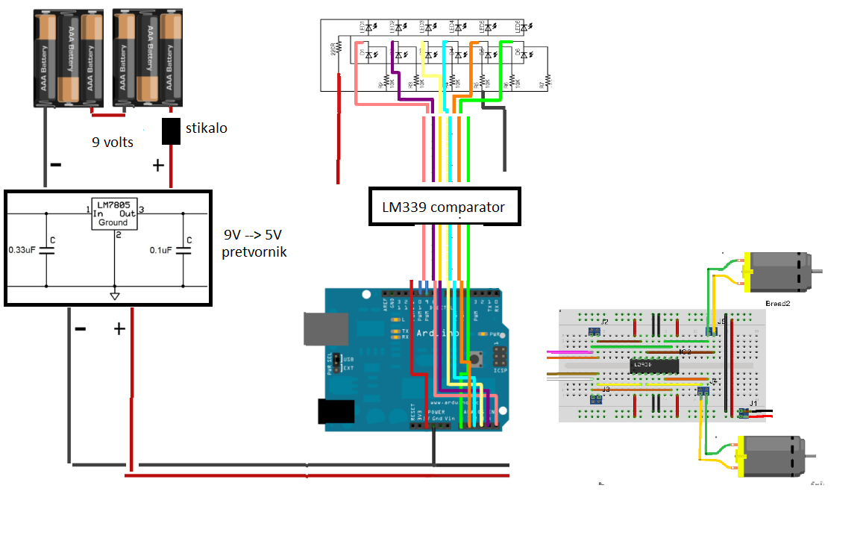

OSNOVNI GRADNIKI:

1. OHIŠJE
2. Baterije 6 * 1,5V = 9V
3. Regulator napajanja 5V
4. ENOSMERNI MOTORJI
5. H bridge krmilnik L293D
6. KRMILNIK ENOSMERNIH MOTORJEV (H-BRIDGE)

# OHIŠJE

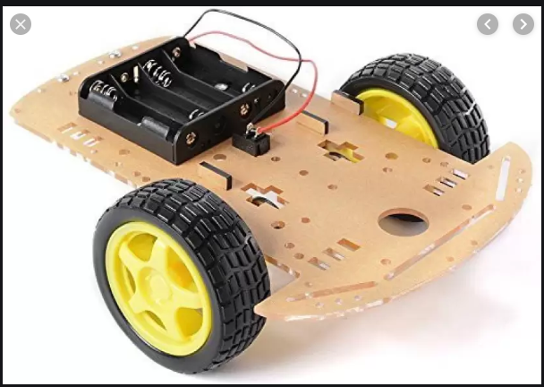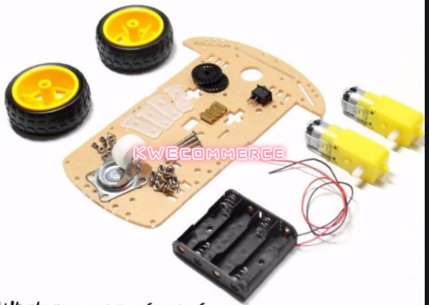

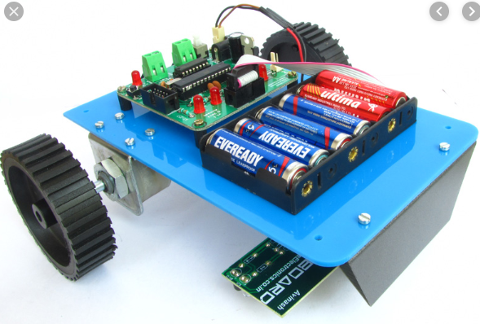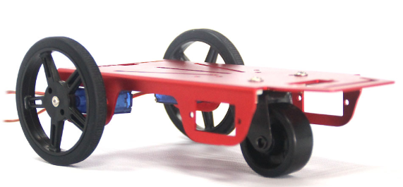

# Regulator napajanja 5V

Komponente:

* 1x LM7805: 5V regulator napetosti
* 1x dioda

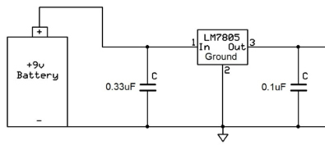

# ELEKTROMOTOR

# IR LED ARRAY

**LM 324**

**LM 339**

**LM 358**

Marko nabavil: Senzor ovir IR - 4 kanalni LM 339

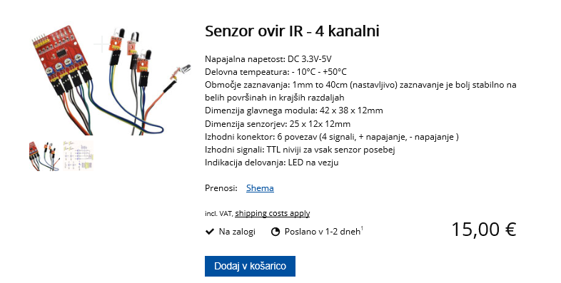

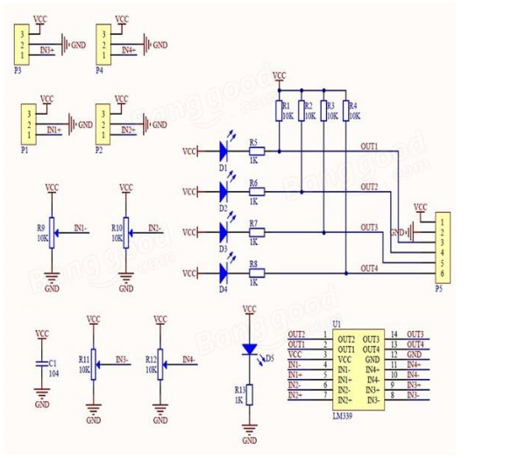

# LED ARRAY

3.a) ENOJNA VERZIJA

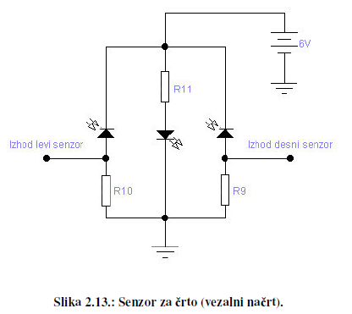

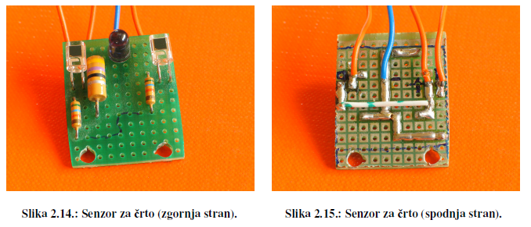

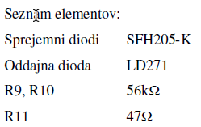

3.b) ENOJNA VERZIJA

3.c) enojna verzija izboljšana

<https://www.electronicshub.org/ir-sensor/>

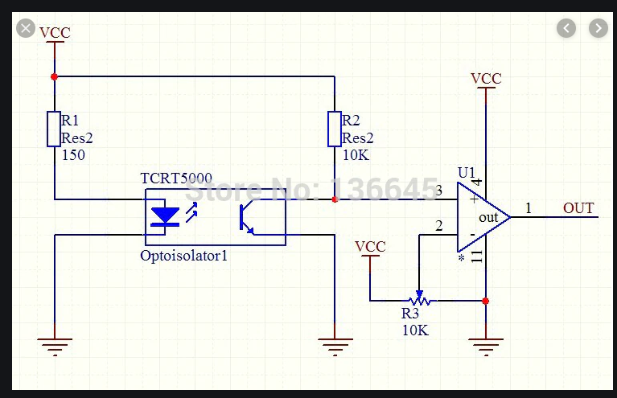

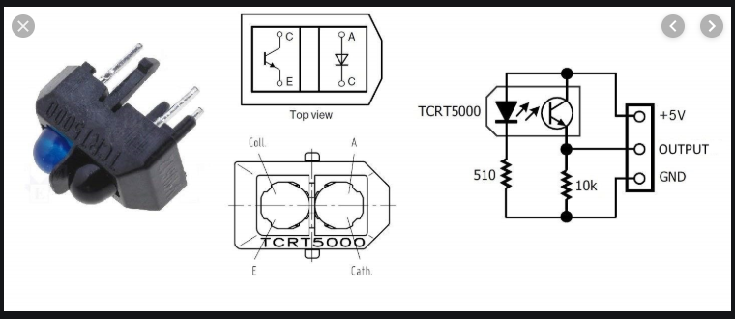

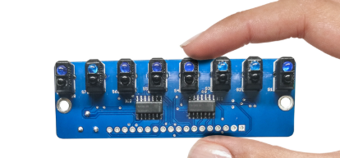

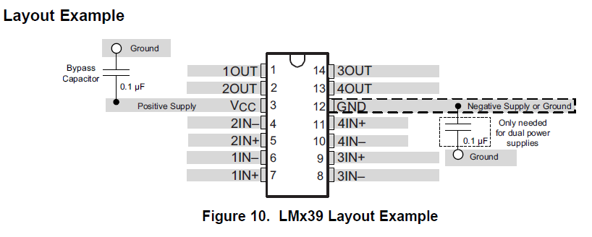

# Modul : L293DNE H BRIDGE MOTOR DRIVER

## Informacije: datasheet, internet

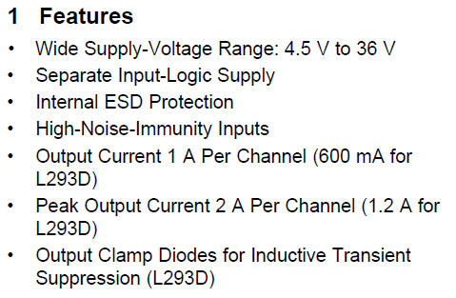

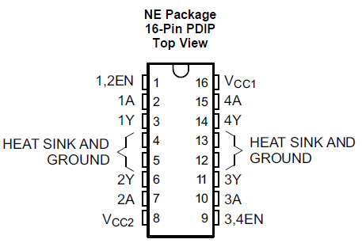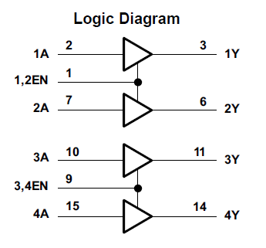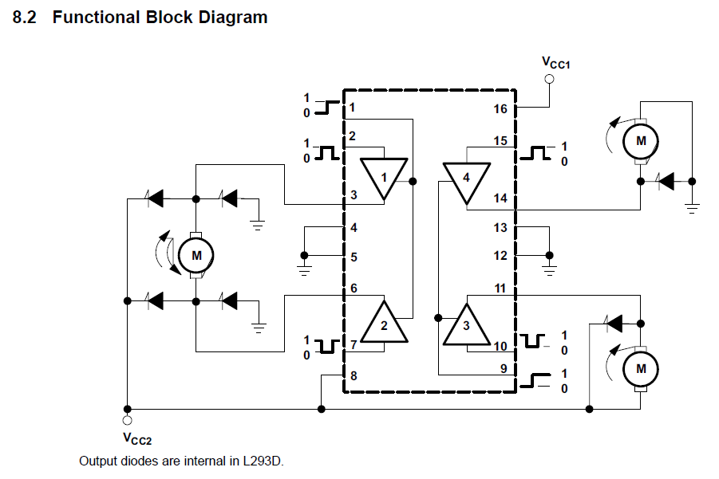

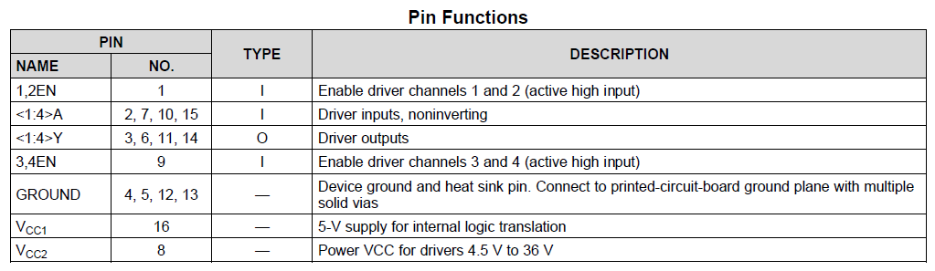

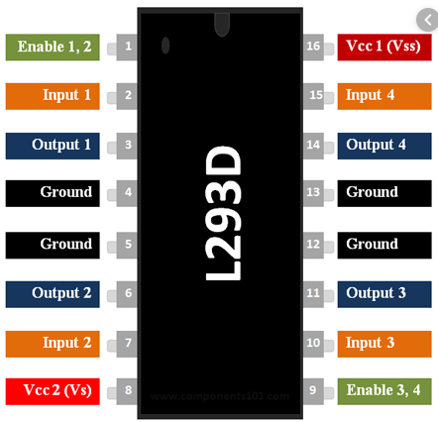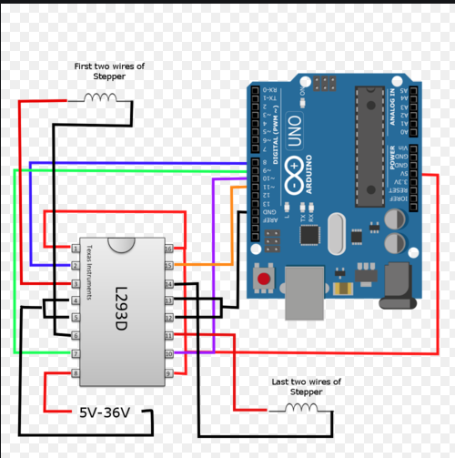

## IZDELAVA

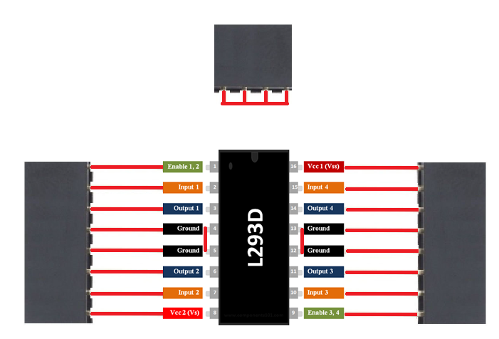

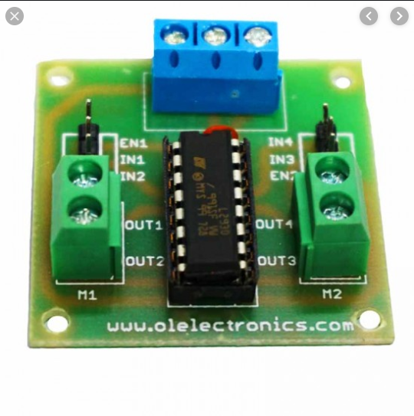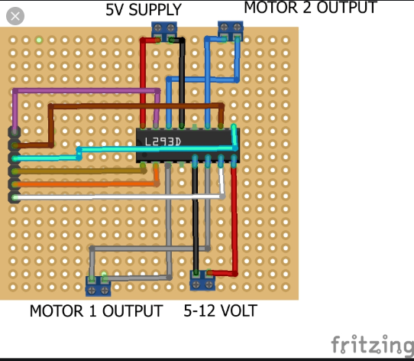

# Opombe

* 3 x fine klešče za ščipanje žice
* 3 x pince za krivljenje žice
* 1 x alphawire tinned copper 20 awg mil-w-3861 type s, qqw 343 type s,

Bolj tanka kot 20 awg